**Exercise 12 – Registration (29.January.2018 16h-17h)**

**Challenge 1 - How many rice grains are present in the image?**

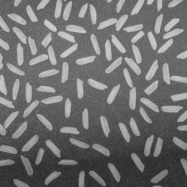

This should be as automatic as possible.

Tips:

* Use filter for edge detection
* Use filter based in Fourier transform
* Use morphological operators (needs binary image)

Will it work if you are given a similar image?

**Challenge 2 – Where is Waldo?**

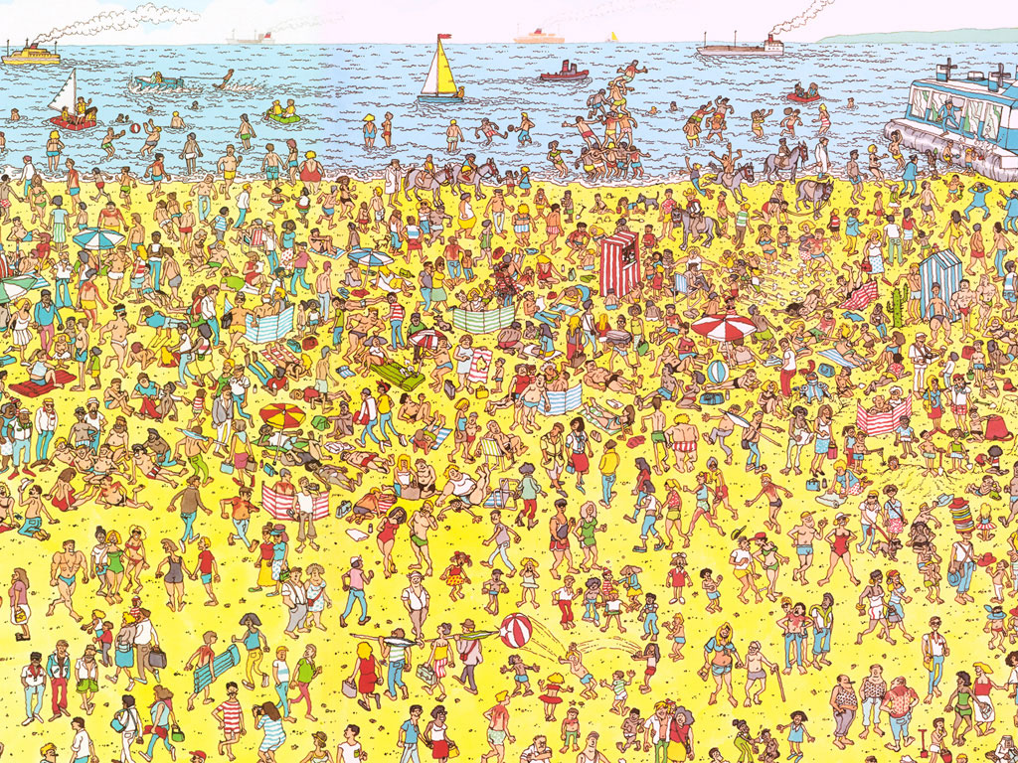

This should be as automatic as possible.

Tips:

* Divide the image in different color channels
* Check for horizontal patterns
* Use a Wally template and similarity metrics

Will it work if you are given a similar image?